**LAB 5**

**IP Address Configuration IN WINDOWS**

In this lab you will learn how to retrieve and modify IP address configuration of a Windows 10 PC.

1. You will need a Windows 10 VM:
   * can use your Windows 10 VM from the previous semester, in the ‘Hardware & Desktop Operating Systems (HDOS)’ course,
   * or download the latest Windows 10 VM (as OVA file) from our NAS:
     + \\on-nas.howest.be\TI-StudentShare\TI-S2-ComputerNetworks or via <http://gofile.me/48XmW/uAtasicZ9> (VPN required).
     + Double-click the OVA file to import it into your VMware Workstation.
     + Make sure that the VM is stored in a folder on your laptop that you do not sync with a cloud solution!
     + The VM has a user: ‘Mickey’, with password: ‘Mouse’

Even more interestingly is to do the first part (the steps where you only inspect settings, without modifying) on your own laptop host operating system if you are running Windows 10 and if you’re interested in your own settings or if you are waiting for the VM download to complete.

1. Show, **using** **the GUI,** all network adapters on your host (laptop). Note, this is not in the “Settings” interface (this is not detailed enough for you as IT person), the window should have the ‘Network Connections’ title. Paste below a screenshot of the window in which you found this info.

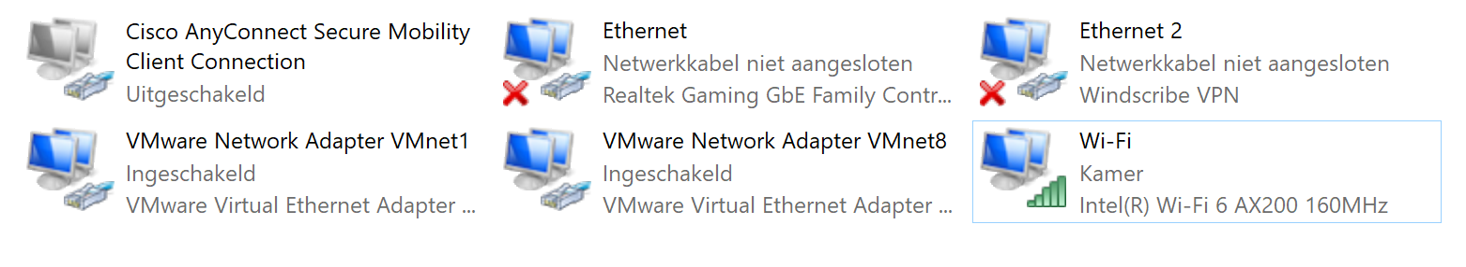

1. Show all network adapters on your host using **Powershell-cmdlet** below.

***Get-Netadapter***

Paste below a screenshot of the output of this command.

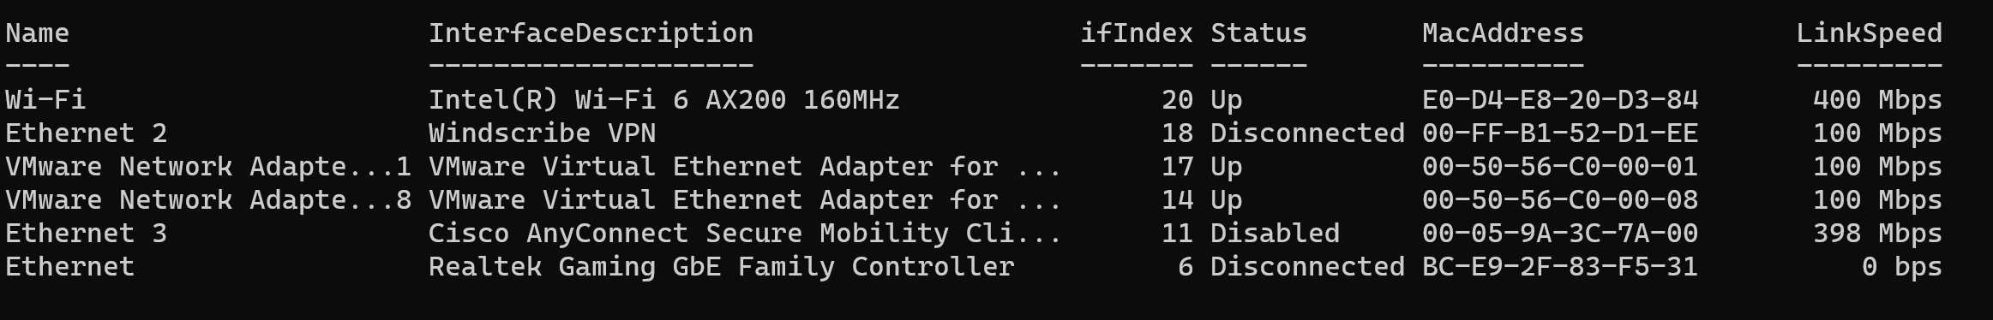

Note that on your host Windows 10, you’ll see both physical and virtual (from VMware) network adapters. In your VM itself, the adapters appear to be actually physical.

Also note that each network adapter has an interface index number (ifindex).

With which PS-cmdlet can you retrieve the MAC address of your wireless network card only? (or the MAC address of your Ethernet network card only within the VM)

Hint 1: Remember how to use cmdlets with parameters and how to then pass it on to filter out specific information you need

Hint 2: Use the index no of that interface.

Get-NetAdapter -ifindex 20 | select MacAddress

1. The cmdlet from the previous exercise allows you to retrieve physical information about network cards, but no information about IP addresses. With the cmdlet below you can do this (partially).Test this out!

**Get-NetIPInterface**

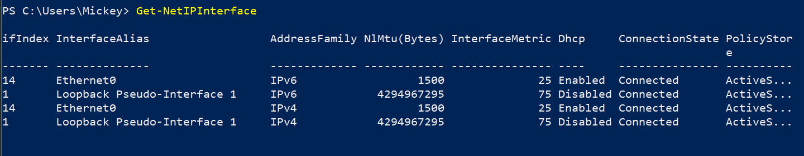

This allows you to check, among other things, whether IPv4 and/or IPv6 are used and whether the IP addresses are static (manually configured) or dynamic (obtained via DHCP).

Adjust your cmdlet on your host so you can see all the IPv4 properties of only your wireless network card (or only your Ethernet network card in the VM). Note this cmdlet below.

Get-NetIPInderface -ifindex 14 -AddressFamily IPv4 | select *

Can you find the IPv4 address of your wireless NIC (or Ethernet NIC) in that output?

No

1. To get IP address info about your network cards, use the cmdlet below.Test this out!

***Get-NetIPAddress***

Adjust this cmdlet so you only get IPv4 address information about your wireless network card.

Get-NetIPAddress -ifindex 14 -AddressFamily IPv4

1. Use **the GUI** to retrieve and fill in the following data about your host’s wireless network card (laptop).

* **IPv4 address: 192.168.219.129**
* **Subnet mask: 255.255.255.0**
* **Mac address: 00-0C-29-70-12-E8**
* **Type of IPv4 address (static or dynamic): dynamic**
* **Default gateway: 192.168.219.2**
* **DNS server: 192.168.219.2**
* **IPv6 address: fe80::e5:a62c:9ec6:79d0**

Paste below a screenshot of the window in which you found this info.

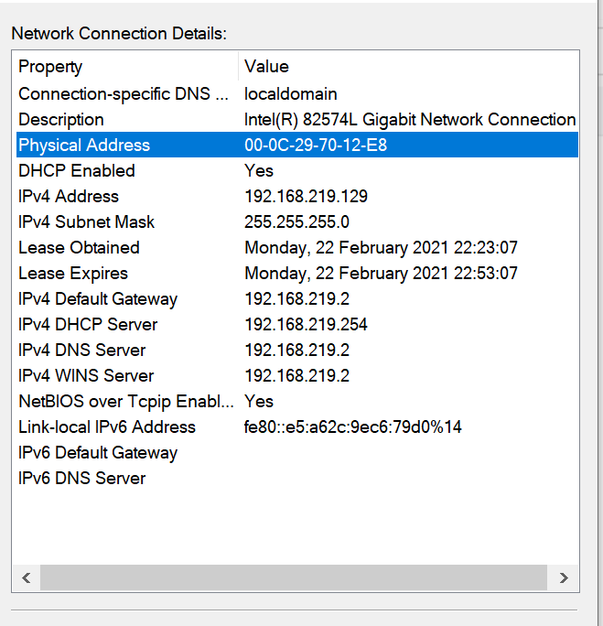

1. With the **ipconfig** legacy Windowscommand you can also access IP config information. What option do you need to provide to also obtain all data from the previous question? Execute that command!

Ipconfig /all

1. VMware Workstation uses a NAT network by default (more on NAT later): a virtual machine is created in a protected private network by default, and the network card in the VM is given an IP address from the built-in (virtual) DHCP server of VMware.



Some characteristics of the standard NAT network (which is called ‘VMnet 8’):

* IP address range:192.168.x128-192.168.x.254
* Subnet IP address:192.168.x.0
* Default gateway:192.168.x.2
* IP address DHCP Server:192.168.x.254

x represents an arbitrary number between 0 and 255.

Check the number VMware uses for your Workstation installation and write it down below.

Tip: Use the *Edit* > *Virtual Network Editor* menu in VMware.

**x = 219**

Note that this number is changed when reinstalling VMware Workstation!!!

1. **From here on, work in your Windows VM and no longer on Windows of your host (laptop), as we’ll make changes to the IP configuration.**

Using an legacy Windows command, request the IPv4 address of your VM’s NIC and write it down below;

**IPv4 address = 192.169.219.129**

So normally the third number of this address must match the value of x from the previous question...

1. Check if you can ping **from your host machine** to the IPv4 address of your Windows-VM.

Whether this works, will depend on the configuration of the Windows Defender Firewall on your VM.If you have never modified it, this will not work because **the Windows Defender Firewall blocks incoming ICMP packets (send by the PING command) by default**. If you have run lab the HDOS labs correctly (and so you have modified the firewall correctly), this will work. Else, you still have to enable the firewall rules for File and Printer sharing (open ‘Windows Defender Firewall with Advanced Security’ or wf.msc to do this). In any case, make sure this works from now on.

1. Change **the dynamic IPv4 address of the NIC of your Windows 10 VM to a fixed IPv4 address with the following configuration, using a PS-cmdlet**:

* IPv4 address: 192.168.X.10
* Subnet mask: 255.255.255.0 (corresponding to a prefix length of 24, more on that later)
* Standard gateway: 192.168.X.2

Here you have to replace X with your “own” value (see earlier).

Tip: use the following cmdlet:

***New-NetIPaddress***

New-NetIPAddress –ifindex 4 –IPAddress “192.168.219.10” –PrefixLength 24 -DefaultGateway 192.168.219.2

Check if you can ping from your host to this newly set address. So, normally, that should work.

1. Check if you can surf on your Windows 10 VM.

The reason this is not working is because a DNS server has not been set up yet.You can't do that with the *new-netipaddress* cmdlet.

Use the cmdlet below to also configure a correct DNS server for the NIC of your VM:

***Set-DNSClientServerAddress***

Set-DnsClientServerAddress -interfaceindex 4 -ServerAddresses 192.168.219.2

Then check if you can surf on your VM now.

1. Using the GUI, change the fixed IP address you set in the previous command back to a dynamic address and paste below a screenshot of the window where you set it.

Then check if you can still surf.

